# **Pull Request Workflow**

When working with Pull Requests, consider the following workflow.

## **Review & Merge**

* First, create a repository, and add any collaborators via the settings panel.
* On your local machines, create and work on local branches.
* When you're satisfied with the changes you've made to your local branch and want to merge it into master, push the branch to GitHub.
  + i.e., run: git push origin <branch_name>
* Navigate to your GitHub repository in the browser, and select your branch from the drop-down on the home page.

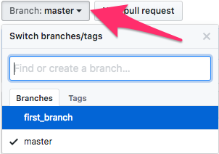

* Open a pull request against your branch.

create-pr.png

* Fill out the form that pops up, and press Create Pull Request.
* Be sure to discuss who is responsible for reviewing PRs, and when.

# **Git Pull Workflow**

Refer to the following document when interacting with GitHub.

## **Pull Reference**

The syntax for pull mirrors that of push.

git pull origin master

To pull from GitHub to a branch *other than master*, we simply checkout and specify the branch.

git checkout other_branch

git pull origin other_branch

To simultaneously pull and merge most recent version of master into the branch you're currently on, simply pull from origin/master while on origin master *into* <other_branch>.

git checkout other_branch

git pull origin master

This checks out other_branch; fetches changes to master from GitHub; and then merges them into other_branch.

In order to avoid issues with merge conflicts, you should always git pull before merging or pushing.

git checkout master

# Do some work, add, commit

git push origin master

git checkout other_branch

# Do some work, add commit

git checkout master

git pull

git merge other_branch

git push master